 **HARAMAYA UNIVERSITY**

**COLLAGE OF COMPUTING AND INFORMATICS**

**DEPARTMENT OF INFORMATION TECHNOLOGY**

**ASSIGNMENT OF ENTERPRENEURSHIP AND SMALL BUSSINESS**

SUBMITED BY:

No NAME ID No

1. Semira Sherefa………………………….401/08

Submitted to : Dr.Dhamodaran

May, 2019

# 

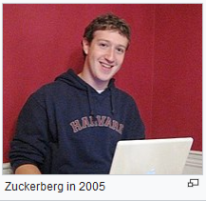 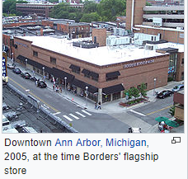

**Mark Elliot Zuckerberg**

**Age:** 34

**Birthplace:** White Plains, New York, United States of America

**Attended**: Harvard University

**Profession:** Programmer, Businessperson, Entrepreneur

**Country:USA**

* Originally launched to select college campuses, the site expanded rapidly and eventually beyond colleges, reaching one billion users by 2012.
* Zuckerberg took the company public in May 2012 with majority shares. His [net worth](https://en.wikipedia.org/wiki/Net_worth) is estimated to be $55.0 billion as of November 30, 2018, declining over the last year with Facebook stock as a whole.
* In 2007 at age 23 he became the world's youngest self-made billionaire.
* As of 2018, he is the only person under 50 in the [*Forbes*](https://en.wikipedia.org/wiki/Forbes) ten richest people list, and the only one under 40 in the Top 20 Billionaires list.
* The Facebook founder had an estimated net worth of over $71 billion in March 2018.
* In January 2013, Zuckerberg [reduced his annual salary base to $1](https://www.sec.gov/Archives/edgar/data/1326801/000119312513178090/d493645ddef14a.htm).
* Though he retained 17% of Facebook's stock in 2012, he and his wife have pledged to give away over 99% of their stake during their lifetimes.
* Mark Elliot Zuckerberg is an American computer programmer and Internet entrepreneur. He is best known as one of five co-founders of the social networking website Facebook.
* Zuckerberg was made the chairman and chief executive of Facebook, Inc. in April 2013. and his personal wealth, as of March 2015, is estimated to be $35.1 billion. Mark
* Zuckerberg receives a one-dollar salary as CEO of Facebook. Together with his college roommates and fellow Harvard University students Eduardo Saverin, Andrew McCollum, Dustin Moskovitz, and Chris Hughes,

### BORDERS cAMPANY

**Located**: in Ann Arbor, Michigan, where it was

**Founded:** in 1971 by brothers Tom and Louis Borders

**Graduate:** University of Michigan.

**About company failure**

* Borders was an international book and music retailer
* Locations all around the world but mounting debt, Border was unable to transition to the new business environment of digital and online books
* Its missteps included holding too much debt, opening too many stores as well as jumping into the e-reader business to late.
* The last year that Borders made a profit was in 2006. Its yearly income dropped by $1 billion over the next four years.
* Borders closed all of its retail locations and sold off its customer loyalty list, comprising millions of names, to competitor Barnes & Noble for US$13.9 million.
* All 200 closings will be superstores, and about 6,000 jobs will be affected, the company said. It has the option of closing up to 275 in all, according to court documents. It said the stores it wants to close lose a combined $2 million a week.